Basic Guide to
Wisconsin Small Claims Actions
This guide is provided by the Wisconsin court system to give you general information about Wisconsin small claims actions. Resources available in each county may be found at the link below:
https://www.wicourts.gov/services/public/selfhelp/docs/countylegalresources.pdf
For additional information, please see the Pre-Judgment and Post-Judgment Basic Steps Documents. These basic steps documents and any forms mentioned in this basic guide may be obtained from the clerk of court or online at:
https://www.wicourts.gov/forms1/circuit.htm.
In addition to the guidance in this handbook, follow local court rules or procedures:
Wisconsin Circuit Court Rules
NOTICE: Small Claims laws change often. The small claims forms are intended to be useful in many cases, but you may have to add or attach additional information as it applies to your case. Talk to a lawyer if you are unsure whether these forms are the most appropriate for your situation.
Court staff cannot give legal advice.

General Information About Small Claims Court
What is Small Claims Court?
Small Claims Court is a special court where disputes are resolved more quickly and inexpensively than in other court proceedings. The rules in Small Claims Court also are simpler and less formal. The person who sues is called the plaintiff. The person who is sued is called the defendant.
What terms are used in Small Claims Court?
All terms are defined in the Glossary which can be found starting on page 14.
What kinds of cases go to Small Claims Court?
The most common types of small claims cases are:
- Claims for money: where the amount claimed is $10,000 or less, if the actions are:
- For money judgments only, or
- For garnishment of wages.
- Claims for tort/personal injury: where the amount claimed is $5,000 or less.
- Claims for eviction: regardless of the amount of rent claimed.
- Claims for replevin (return of property):
- Non-consumer credit actions where the value of the property claimed is $10,000 or less;
- Consumer credit transactions where the amount financed is $25,000 or less.
Less common types of small claims cases include:
- Return of earnest money for purchase of real property
- Action on an arbitration award for the purchase of real property
- Eviction action due to foreclosure
See also §799.01(1), Wis. Stats., the Legal Glossary (page 14 of this document),
- Pre-Judgment: Basic Steps for Handling a Small Claims Case for Eviction, (SC-6010V),
- Pre-Judgment: Basic Steps for Handling a Small Claims Case for Recovery of Money, (SC-6020V), and
- Pre-Judgment: Basic Steps for Handling a Small Claims Case for Replevin (Recovery of Property), (SC-6030V) for further information.
What is a tort or personal injury action?
A tort is a wrongful act that injures someone, where the injured person may sue the person/business causing the injury for money damages. The injury may be to a person’s body, property, business, reputation, or other interest. The act may be the result of carelessness (“negligence”) or may be intentional. A tort is different from a breach of contract or a crime.
For more information about torts/personal injury actions, please see Appendix A: “Personal Injury – Helpful Information” at the end of this document.
Who can sue in Small Claims Court?
Any person who is 18 years or older.
Do I have to have an attorney?
Whether to hire an attorney is your decision. Many people feel that they can handle their legal matters without an attorney in Small Claims Court. When you represent yourself in court without an attorney it is called “self-representation” or “pro se.”
Even if you do not intend to hire an attorney to represent you in Small Claims Court, you may wish to contact an attorney for advice. An attorney may be able to advise you whether you have a valid claim or defense, about the types of evidence you will need to prove it, and may even be able to assist you in settling your case. If you cannot afford an attorney, there are organizations that may be able to assist you.
Court staff may only provide general information about court rules, procedures, practices, and forms. Court staff cannot give you legal advice. For instance, this means court staff cannot tell you which form(s) to use, or assist you in filling out the form, and cannot interpret terms or court orders.
Try to settle first!
To avoid the time and expense of going to court, try to settle the matter first. Contact the other party or the party’s attorney, discuss the situation, and try to solve the problem by an agreement you can both accept. Even after your small claims suit is filed, you may still engage in settlement negotiations with the opposing party. Don’t be reluctant to compromise; even in large civil lawsuits, more than 90% are settled prior to trial.

Small Claims Pre-Judgment Flowchart
Even though each county may do things a little differently or call various hearings by different names, there is a basic structure to how a small claims action will proceed in Wisconsin. The flowchart below is a brief representation of the process.
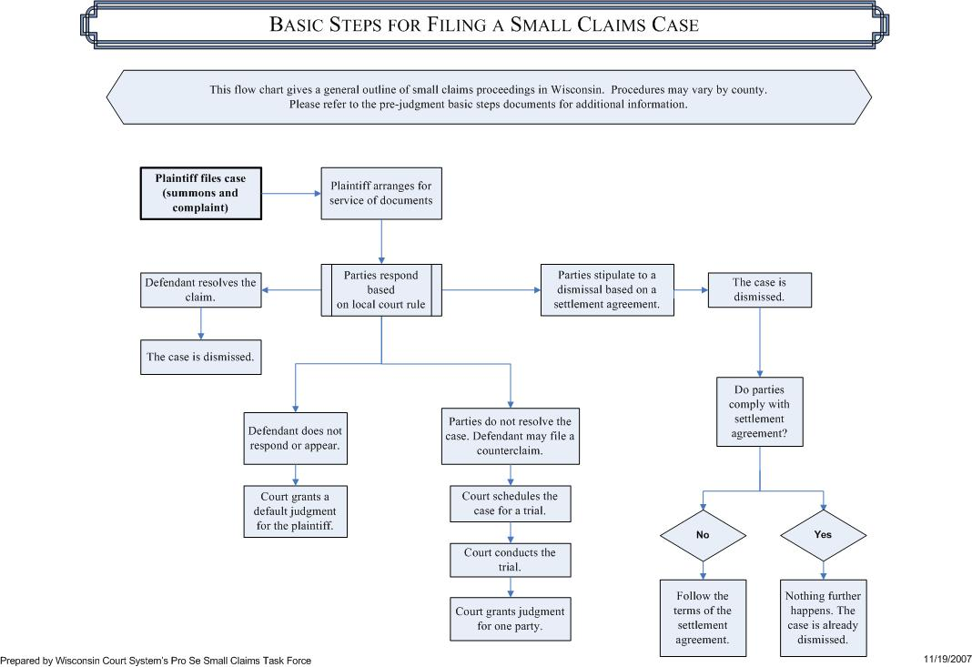

However, there are different procedures for the various types of small claims actions that can be filed. Also, there may be specific procedures that you must complete in some counties. Please refer to:
- Pre-Judgment: Basic Steps for Handling a Small Claims Case for Eviction, (SC-6010V),
- Pre-Judgment: Basic Steps for Handling a Small Claims Case for Recovery of Money,
(SC-6020V),
- Pre-Judgment: Basic Steps for Handling a Small Claims Case for Replevin (Return of Property), (SC-6030V),
- Pre-Judgment: Basic Steps for Filing an Answer to a Small Claims Complaint, (SC-6040V), and
- Pre-Judgment: Basic Steps to Small Claims Service, (SC-6050V) for an overview of the basic steps involved in completing these actions.

I WOULD LIKE TO FILE A SMALL CLAIMS CASE.
Who do I sue?
It is important that you sue the right party. Naming the wrong party could result in the dismissal of your case. To assist you, please see Appendix B: “Suing the Right Party” at the end of this document.
Do I have to pay to file a Small Claims action?
Yes. You will have to pay the clerk of court a fee to file your Summons and Complaint, (SC-500) form or Summons and Complaint (with Instructions), (SC-500I) form. This small claims filing fee is set by state law (https://www.wicourts.gov/courts/circuit/docs/fees.pdf). This and certain other fees may be charged against the other party if you win your case.
However, if you cannot afford the filing fee, you may complete the Petition for Waiver of Filing Fees and Costs - Affidavit of Indigency, (CV-410A) and Order on Waiver of Filing Fees and Costs, (CV-410B) form. If the court finds that you cannot afford to pay, the court may waive the filing and service fees.
Where do I file my Small Claims case?
If you determine that your claim can be brought as a small claims case and have determined the right party to sue, you will need to decide where you should file the small claims action.
- Eviction actions. Actions for eviction should be filed in the county where:
- a defendant resides,
- the rented property is located.
- Return of earnest money. Actions for the return of earnest money should be filed in the county where:
- a defendant resides;
- the real estate is located, or
- the purchase contract was signed.
- Replevins. Actions for replevin (return of personal property) should be filed in the county where one of the following is true:
For Non-consumer claims:
- a defendant resides;
- the personal property is located, or
- the claim arose.
For Consumer claims:
- the customer resides or is personally served;
- collateral securing a consumer credit transaction is located, or
- the customer sought or acquired the property, services, money or credit.
- Arbitration. Actions for the confirmation, vacation, modification or correction of an arbitration award should be filed in the county where:
- a defendant resides;
- the real estate is located, or
- the claim arose.
- Other civil actions. In other civil actions where the amount claimed is $10,000 or less, or for torts or personal injury actions where the amount claimed is $5,000 or less, the action should be filed in the county where:
For Money judgments:
- For Non-consumer claims:
- a defendant resides, or
- the claim arose.
- For Consumer claims:
- the customer resides or is personally served, or
- the customer sought or acquired the money or credit which is the subject of the claim or signed the document showing his or her obligation.
For Garnishment:
- the garnishee resides or is located;
- the summons in the original action was issued, or
- the judgment from the original action was entered.
How do I file the Small Claims Case?
Complete the Summons and Complaint, (SC-500) form or Summons and Complaint (with Instructions), (SC-500I) form and make two (2) copies for each defendant. Take the original and copies to the clerk of court’s office for filing and payment of the filing fee.
If you would like to file and manage your case electronically, please visit the Wisconsin Court System website and look for eFiling. Use the Summons and Complaint, (SC-500) form or (SC-500I) form to file your documents and pay your filing fee online.
I have been sued in Small Claims Court.
nOW What do I do?
The first thing you should do is READ THE ENTIRE SUMMONS AND COMPLAINT.
DO THIS NOW!
The Summons and Complaint will tell you:
Who is suing me?
The person suing you is the person listed in the Summons and Complaint as the Plaintiff. You are the Defendant. If the plaintiff has an attorney, the Summons and Complaint will also list the attorney’s name and address.
Must I appear in court?
See the Summons (first page of the Summons and Complaint), which will tell you if you are required to appear in person or can respond in writing. If you are required to appear in person, the Summons will list the date, time and location.
Why am I being sued?
The Summons and Complaint will tell you why the plaintiff is suing you. There are many reasons a claim could be filed. Common examples are:
- If you are renting property, the plaintiff may be your landlord and claims you have not paid your rent or have not lived up to your rental agreement, whether it is in writing or not.
- If you bought a car or some other item on credit, the bank or finance company may claim you are behind on your payments.
- The plaintiff may claim you owe money.
- The plaintiff may claim he or she was injured or the plaintiff’s property was damaged and it is your fault.
What does the Plaintiff want from me?
The Summons and Complaint will tell you what the plaintiff wants from you. Some common examples are:
- If you are renting property, the plaintiff may want rent or money for utility bills that are not paid, or money for damage to the property, AND may want you evicted (removed) from the property.
- If you bought something on credit, like a car, the plaintiff may want to get the car from you plus the money you still owe after the car is sold.
- If the plaintiff claims you owe money, the plaintiff wants money from you.
What if I disagree with what the Plaintiff says?
If you don’t agree with what the plaintiff claims or if you don’t agree with what the plaintiff wants from you, YOU MUST ANSWER THE COMPLAINT.
Counties may have different procedures to answer the Complaint.
See local court rules at: https://www.wisbar.org/Directories/CourtRules/Pages/Circuit-Court-Rules.aspx.
You must answer the Complaint in writing, in person or both. If you need to appear in person to answer the Summons and Complaint, the Summons and Complaint will tell you when and where to appear. If you need to file a written answer, the Summons and Complaint will tell you where to file the answer. See Pre-Judgment: Basic Steps for Filing an Answer to a Small Claims Complaint, (SC-6040V) for more information.
IF YOU DON’T ANSWER THE COMPLAINT PROPERLY, A JUDGMENT MAY BE ENTERED AGAINST YOU.
How do I answer the Complaint in person?
Some counties require you to answer the Complaint in person. If you have to answer the Complaint in person, the Summons will state the court date and where and what time you need to appear.
You must appear on time and it is recommended that you arrive at least 15 minutes early. If you have any questions about where you should appear, go to the Clerk of Court’s office.

IF YOU FAIL TO APPEAR AT THE CORRECT LOCATION AND ON TIME, A JUDGMENT MAY BE ENTERED AGAINST YOU.
When your case is called, be prepared to say if you are or are not contesting the claim. You may want to bring along with you some short notes to help keep yourself organized. If you have a counterclaim and have not already filed it, you should file it at this time and give a copy to the plaintiff.
How do I answer the Complaint in writing?
Some counties require you to answer the Complaint in writing. If you have to answer the Complaint in writing, the Summons will state where to file your written answer. In your answer, state why you disagree with the plaintiff and what defenses you feel you have to the plaintiff’s claim. You may use the small claims Answer and Counterclaim, (SC-5200V) form. The form has step-by-step instructions on the left side to help you fill it out.
When you have completed your Answer and Counterclaim form, follow the instructions in the Summons that tell you where to send the Answer.

You must send a copy of your written Answer to the plaintiff.
IF YOU FAIL TO FILE YOUR WRITTEN ANSWER TIMELY AND PROPERLY, A JUDGMENT MAY BE ENTERED AGAINST YOU.
If you would like to file and manage your documents electronically, please visit the Wisconsin Court System website and look for eFiling (https://www.wicourts.gov/ecourts/index.htm). Follow the steps provided to sign up. You can file the small claims Answer and Counterclaim, (SC-5200V) form online.
What if I have a Claim against the Plaintiff?
If you believe that you have a claim against the plaintiff, you may file a counterclaim, which is the legal term for a defendant’s claim against the plaintiff.
Use the Answer and Counterclaim, (SC-5200V) form to prepare your counterclaim. Clearly describe your claim in your own words. Make sure to include any relevant dates and specific facts. State the amount of money you believe you are owed and also state any other action you are asking the court to take. Think carefully about how much your claim is worth. This is important because the amount of your claim affects how you proceed with your counterclaim and whether there will be a filing fee for the counterclaim (see below: “What if I want to counterclaim for more than $10,000 or I want to file a tort or personal injury counterclaim for more than $5,000?”).
File your counterclaim with the clerk of court in the same county where you are being sued by the plaintiff. Each county can have different procedures for filing a counterclaim, so check with the clerk of court to find out the specific county rules for filing a counterclaim. There is no fee for filing a counterclaim unless your claim is for more than $10,000 or unless you file a tort or personal injury counterclaim that is more than $5,000.
Prepare a copy of your counterclaim for each plaintiff so the clerk can file stamp them and return them to you. You must then have those copies served on each plaintiff. Check local court rules to see if you can serve the counterclaim on the plaintiff by mail or if you must use the sheriff or a process server. There will be a service fee if you use the sheriff or a process server to serve the plaintiff. If you have served the counterclaim on the plaintiff by mail, complete the Affidavit of Mailing, (SC-5130V) form and file it with the clerk of court. If service was done by the sheriff or process server, you must ensure an Affidavit of Service is filed with the court. Follow the local court rules for attending the next court date.
What if I want to counterclaim for more than $10,000 OR I want to file a tort or personal injury counterclaim for more than $5,000?
If your counterclaim demands more than $10,000, or if you want to file a tort or personal injury counterclaim demanding more than $5,000, you will have to pay a filing fee to the clerk of court. You must have the sheriff or process server serve the counterclaim on the plaintiff(s) personally within 60 days of filing and file the proof of service with the clerk of court. Because a counterclaim takes the case over the small claims dollar limit, the case may be transferred to regular civil court for scheduling and further proceedings.
In addition to filing and serving the Answer and Counterclaim, (SC-5200V) form as explained in the previous paragraph, you will also need to file and mail a Notice of Counterclaim, (SC-5250V) form. This should be done on the same day you file the counterclaim. Once you have mailed the Notice of Counterclaim to the plaintiff, complete the Affidavit of Mailing, (SC-5130V) form and file it with the clerk of court.
Can I try to settle the case?
Yes. Some counties may have mediation services available to help you reach an agreement with the other party. You may also contact the other party or the party’s attorney directly at any time to try to reach a settlement agreement. See Stipulation for Dismissal- Eviction, (SC-5300VA and Order for Dismissal- Eviction, SC-5300VB) form, or Stipulation for Dismissal - Non-Eviction, (SC-5310VA and Order for Dismissal - Non-Eviction, SC-5310VB) form.
What if I don’t contest the plaintiff’s claim and have no counterclaim?
If you do not contest the plaintiff’s claim and have no counterclaim, it is not necessary to appear in person or file a written answer. If you do not appear or file a written answer, a default judgment will likely be granted against you and in favor of the plaintiff for what the plaintiff is asking for in the Summons and Complaint, plus statutory court costs.

MY CASE IS GOING TO TRIAL
PREPARING FOR AND PARTICIPATING IN A CONTESTED TRIAL
Refer to Local Court Rules
You must follow local court rules that may not be contained in this guide. Local court rules can be found on the WI State Bar website at: https://www.wisbar.org/Directories/CourtRules/Pages/Circuit-Court-Rules.aspx

or the courts website at: https://www.wicourts.gov/scrules/index.htm.
Now do I need a lawyer?
Before attempting to handle a contested small claims hearing on your own, you should consider seeking legal assistance. There are specific rules that must be followed in a small claims hearing.
Preparing Your Case
Collect and preserve any documents or other evidence needed for trial.
Collect and preserve any documents or receipts from your dealings with the other party. Put them in chronological date order. Evidence on cell phones, computers or other electronic devices must be printed out or saved to a storage device to submit to the court. Making a detailed timeline of all of the events involved (in date order) may help you present your case in a more organized way. It is recommended that you bring copies of all documents for the court and all other parties.
Determine if you will need witnesses.
Determine if you will need witnesses to testify at the trial. Witnesses are people who have personal knowledge of the facts of your case. Friends and relatives may come voluntarily, but business people, police officers and others with no personal interest in the outcome of your case may not. In that case, if the witness lives in Wisconsin, you can require the witness to come to court by having the witness served with a subpoena.
- Subpoena, (GF-126A) form and Certificate of Appearance (Subpoena), (GF-126B) form can be obtained at www.wicourts.gov or without charge from the clerk of court’s office. All Subpoenas must be signed by a court official.
- If you need the witness to bring documents or other evidence to the trial, you need to specifically state what the witness is to bring on the Subpoena form.
- You will need to have the Subpoena served on the witness by the sheriff or a private process server in a reasonable time before the trial.
- You will also need to serve with each Subpoena a check for the witness fee, which is $16.00, plus $0.20 per mile the witness has to travel to and from the courthouse.
An expert witness is a person with special training, experience, or expertise in a field beyond the knowledge of an ordinary person. For example, if your case involves defective merchandise or faulty repairs, a full-time mechanic or repair person with several years of experience may qualify as an expert. The expert witness can charge whatever he or she wishes for the testimony. The standard $16.00 witness fee does not apply to expert witnesses. If you win, the cost of the expert witness, up to $300, can be added to any judgment.
Having the expert witness testify in person is almost always necessary. Merely repeating what your expert told you will probably not be allowed. A written statement or affidavit from the expert witness will not be sufficient.
Participating in Trial
How will the trial be conducted?
Small claims trials are conducted in an informal manner by a judge or commissioner. Parties must treat each other with dignity and respect.
It is recommended that you and your witnesses show up at least 15 minutes early to the assigned courtroom on the date and time of the trial. If there is a bailiff or court clerk present, let him or her know that you have arrived. You should bring any documents related to the facts of the case with you to present at trial. The judge or commissioner may refuse to consider evidence or arguments that are repeated, irrelevant or otherwise inadmissible.
Each party bears the burden of proving his or her claim(s) “by the greater weight of the credible evidence.”
The plaintiff presents his or her evidence first; then the defendant is able to present his or her evidence. After swearing or affirming to testify truthfully, state the facts clearly and concisely. Keep to the key facts and do not discuss side issues unless a question requires it. If you have written documents, or other evidence to support your claim, show them to the judge or commissioner and opposing party, explaining what it is and how it relates to your case. It is recommended that you bring copies of each document for you, the judge, and all parties.
At the conclusion of the plaintiff’s testimony, the judge or commissioner may ask some questions. The defendant then has the right to cross-examine the plaintiff. When that is completed, the plaintiff may call any other witnesses he or she has. The judge or commissioner may ask questions and the defendant may cross-examine any of the plaintiff’s witnesses.
The defendant follows the plaintiff and presents his or her case in the same way. The plaintiff may cross-examine any of the defendant’s witnesses.
Following the presentation of the defendant’s evidence, the plaintiff may present rebuttal evidence.
After all the evidence has been presented, the judge or commissioner will state the decision or issue a written decision at a later date.

I won a small claims action.
now what happens?
The clerk of court will enter a judgment in the court record; each party will receive notice of the entry of judgment.
Can I recover my costs?
If you win a small claims case, the judgment will include statutory costs and fees. Statutory costs and fees may include:
- the filing fee for the case;
- the mailing fee for the Summons and Complaint, or the service fees, if you had to have your case served by the sheriff or a process server;
- witness fees, if the witness was subpoenaed and paid the statutory fee to attend, or
- limited attorney fees, if an attorney appeared with you in court.
Not all costs will be included in the judgment. For example, you cannot recover lost wages for appearing in court or parking and transportation costs for coming to court. You also cannot recover attorney fees for consulting with an attorney about your case, if that lawyer did not formally appear with you in court.
How do I enforce the judgment?
If you are granted a money judgment, the other party will be required to complete a Financial Disclosure Statement, (SC-506B) form and send it to you within 15 days of entry of judgment unless they have already paid. If the other party does not complete the disclosure, you may file a Motion and Request for Hearing on Contempt, (SC-507A) form and Order for Hearing on Contempt, (SC-507B) form.
The court does not collect your judgment for you, but there are actions you can take to collect your judgment. See:
- Post-Judgment: Basic Steps for Docketing a Judgment for Collection, (SC-6060V),
- Post-Judgment: Basic Steps for Handling a Small Claims Earnings Garnishment,
(SC-6070V),
- Post-Judgment: Basic Steps for Handling a Non-Earnings Garnishment (SC-6071).
- Post-Judgment: Basic Steps for Handling an Execution Against Property, (SC-6080V),
- Post-Judgment: Basic Steps in Collecting on a Judgment for Money, (SC-6090V), and
- Post-Judgment: Basic Steps in Collecting on a Judgment for Replevin, (SC-6100V).
If you are granted a judgment of $500 or more for damages arising out of a motor vehicle accident, you can request that the clerk provide a certified copy of the judgment to the Division of Motor Vehicles (DMV). In most instances, the DMV will then suspend the operating privilege and all registrations of the debtor:
- Complete the Certificate of Judgment form (MV3158), available on the DMV website: https://wisconsindot.gov/pages/global-footer/formdocs/default.aspx
- Provide the completed Certificate of Judgment form to the clerk, along with the required fee.
The clerk will review the case information included on the form, then sign and affix the clerk’s seal, and send to the DMV.

Small Claims Post-Judgment Flowchart
Even though each county may do things a bit differently, there is a basic structure to the small claims post-judgment process in Wisconsin. The flowchart below is a brief representation of the steps one may take to enforce judgments.

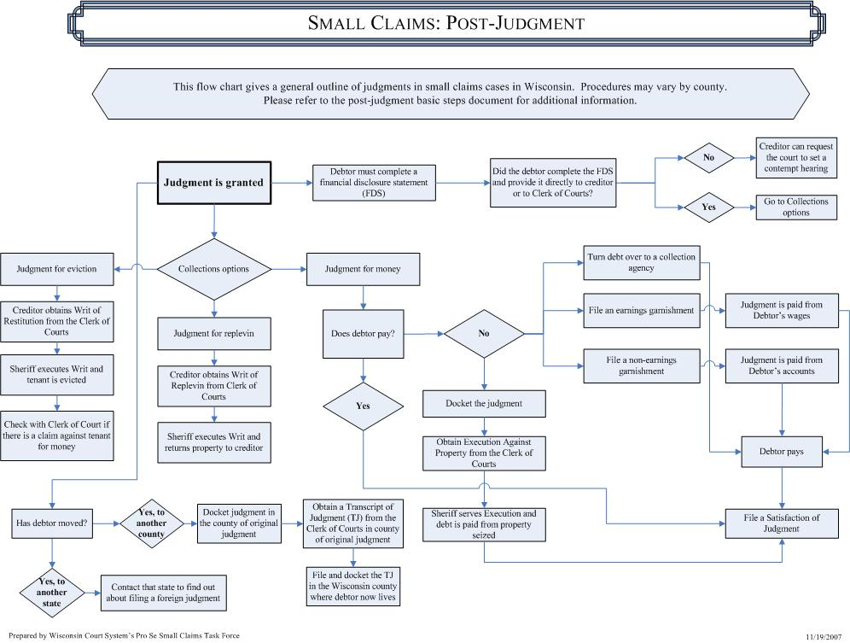

I DISAGREE WITH THE OUTCOME OF THE SMALL CLAIMS CASE.
Can I appeal the decision?
If a commissioner made the decision in your case, you may request a trial before a judge. If the commissioner made the decision at the hearing, you have 10 days from the hearing date to file a demand for trial. If the commissioner issues a written decision, you have 15 days from the date of mailing to file a demand for trial. You must complete the Demand for Trial and Instructions, (SC-517) form, and file the form in the clerk of court’s office in the same county where the commissioner heard your case. The party demanding the trial must mail a copy of the Demand for Trial and Instructions to the other party within the time limits. The party filing the demand for trial is responsible for providing proof that the form was mailed to the other party.
If a judge has made the decision in your case and you are dissatisfied with that decision, you may appeal that decision to the Wisconsin Court of Appeals. The circuit court does not provide any forms for appeals. The rules for filing an appeal are complex. On the Wisconsin Court System website in the self-help center, you will find a publication entitled “Guide to Appellate Procedure for the Self-Represented”.
- Clerk of the Wis. Supreme Ct. & Ct. of Appeals, Guide to Appellate Procedure for the Self-Represented . https://www.wicourts.gov/publications/guides/docs/proseappealsguide.pdf
- The State Bar’s Appellate Practice Section offers an online Appellate Help Desk for people who are representing themselves in a Wisconsin civil appeal. https://www.wisbar.org/forPublic/INeedaLawyer/AppellateHelpDesk/Pages/Appellate-Help-Desk.aspx
You may wish to contact an attorney about filing an appeal. There are strict time limits for filing an appeal, so if you think you may appeal your small claims case do not delay in making that decision.
Can I reopen the Small Claims case?
- Service by mail not received:
If service of the Summons and Complaint was by mail, you never received it, and a judgment was entered against you, you may petition the court to set aside the judgment. You must file the petition within 15 days of receiving actual knowledge of the case or judgment. This option is not available to you more than one year after the judgment was entered. See Petition to Answer or to Reopen Small Claims Action with Mail Service, (SC-511A) form and Order on Petition to Answer or to Reopen Small Claims Action with Mail Service, SC-511B) form.
- Improper Venue:
If a default judgment was entered against you and you believe the case was filed in the wrong county, you may file a motion to reopen the case. This must be done within one year of entry of the default judgment. If the court finds the venue was improper, it will reopen the case. See Motion to Reopen Small Claims Judgment, (SC-515A) form and Order on Motion to Reopen Small Claims Judgment (SC-515B) form.
- Default Judgment/Judgment of Dismissal:
If you have a good reason for missing court or failing to meet court requirements, you may file a motion to reopen the case within 12 months after the judgment was entered. The court will determine whether you have a good reason to reopen the judgment. If the court reopens the judgment, you will be notified. See Motion to Reopen Small Claims Judgment, (SC-515A) form and Order on Motion to Reopen Small Claims Judgment (SC-515B) form.
SATISFACTION OF judgment.
How do I satisfy a judgment?
A judgment may be satisfied when it has been paid. If you have paid the judgment, the plaintiff must sign the Satisfaction of Judgment, (GF-129) form at your request. You must make this request directly to the plaintiff, not through the court. Plaintiff’s failure to sign and file or return the satisfaction within 7 days may result in an award of damages against the plaintiff.
If you wish the court record to reflect that the judgment has been satisfied, you must file the Satisfaction of Judgment. There is a fee for filing the satisfaction. Once the satisfaction is filed, the court record will reflect that the judgment has been satisfied.
Legal Glossary
Although small claims procedure is designed to be simple and easy to use, you will still come across some legal words and phrases when going through the court system. If you need help, look at our legal glossary to find out what some of these words and phrases mean.
ACTION | A lawsuit.
ADJOURN | To delay a hearing until a future time.
ADVERSE PARTY | Party on the other side of the lawsuit.
AFFIDAVIT OF NON-MILITARY SERVICE | Statement that, to the best of plaintiff’s knowledge, the defendant is not now in the military.
AFFIRMATIVE DEFENSE | A new matter, which assuming the complaint to be true, constitutes a defense to it.
ANSWER | A statement by the defendant in response to the plaintiff’s complaint.
APPEAL | A request that a higher court review and change the final decision in a case.
ARBITRATION | A form of alternative dispute resolution where an unbiased person or panel renders an opinion as to responsibility for or extent of a loss.
BUSINESS DAYS | Any calendar day except Saturday or Sunday and except the following business days: New Year’s Day, Martin Luther King Jr.’s Birthday, Washington’s Birthday, Memorial Day, Independence Day, Labor Day, Columbus Day, Veterans Day, Thanksgiving and Christmas, and that is not a legal or federal legal holiday.
CALENDAR | A schedule of cases to be heard in court.
CALENDAR DAYS | Any one of the seven days in a week.
CAPTION | The heading of a court paper, showing the court, county, names of parties and case number.
CLAIM FOR MONEY | A legal action in which a plaintiff argues that a defendant is indebted to the plaintiff for an amount of money.
CLERK | An administrative officer of the court.
COMPLAINT | The court paper that states why the plaintiff is suing and what plaintiff wants the court to order.
CONSUMER | An individual customer buying goods or services primarily for a personal, family or household purpose.
CONTRACT | An agreement.
COUNTERCLAIM | A claim entered by a defendant as a response to or as a defense against an earlier claim made against the defendant by the plaintiff.
COURT COMMISSIONER | An attorney authorized to conduct hearings and initial proceedings.
COURT TRIAL | A trial in which the judge serves as the trier of fact.
CREDITOR | A person who is owed money.
CROSS-EXAMINE | To question a witness for the opposing side in a hearing or trial
CUSTOMER | An individual buying goods or services.
DAMAGES | The amount of money requested in a lawsuit to compensate the plaintiff for injuries to person or property or for the defendant’s failure to perform a contract.
DEBTOR | A person who owes money.
DEFAULT | Failure to answer a complaint or appear for a hearing.
DEFENDANT | The person who is sued.
DEFENSE | A reason why a claim in a complaint is not valid.
DISMISSAL | A court order terminating a case because the plaintiff has failed to appear in court or state or prove a valid claim.
DOCKET | (see Judgment and Lien Docket)
EMANCIPATION | When a child is no longer legally under a parent's control. In Wisconsin, a child is emancipated when he or she turns 18 years of age or marries.
EVICTION | An action by a landlord to remove a tenant from the landlord’s property.
EVICTION DUE TO FORECLOSURE | An action to remove a tenant whose tenancy is terminated as a result of a foreclosure judgment and sale.
EVIDENCE | Objects, information or statements that demonstrate or prove something.
EXAMINE | To ask questions of a witness or other party to a case in a court of law.
EXECUTION | A legal procedure in which the sheriff seizes a debtor’s property to pay a judgment.
EXEMPTION | A law allowing a debtor to keep some property free from the claims of creditors.
EXHIBIT | A paper or thing shown to a court during a hearing and used as evidence.
FEE | A charge fixed by the law for the service of public officers.
FORECLOSURE ON RESIDENCE | Residential real property where there is a delinquency or default on any loan payment or debt secured by or attached to the residential real property, including land contract payments.
GARNISHEE | In garnishments, the party who owes money to the debtor and is ordered to pay it to the creditor instead.
GARNISHMENT | A proceeding after judgment authorizing the creditor to be paid from the debtor’s wages or bank accounts.
GUARDIAN AD LITEM | An attorney appointed by the court to take legal action on behalf of a minor or an adult not able to handle his or her own affairs.
HEARING | The examination of a certain aspect of a case or the trial of a case in a court of law.
JUDGMENT | Final determination by the court.
JUDGMENT AND LIEN DOCKET | An official list of court judgments.
JURY TRIAL | A trial in which the jury serves as the trier of fact.
LIEN | The legal right to keep or sell somebody else’s property as security for debt.
NON-CONSUMER | An individual or business customer buying goods or services for business reasons and not primarily for a personal, family or household purpose.
NOTARY PUBLIC | An attorney or other official authorized to certify the signing of sworn documents.
PARTY | A plaintiff or defendant in a case.
PLAINTIFF | The party who begins a lawsuit.
PREJUDICE (with) | Dismissal with prejudice means that the case cannot be filed again in the Circuit Court.
PRETRIAL CONFERENCE | A meeting between the parties, sometimes including a judge or court commissioner, to investigate settlement or narrow the disputed issues.
PRO SE | Latin meaning “for oneself,” i.e., without the aid of an attorney.
PROOF OF SERVICE | That the delivery of a legal document such as a writ or summons was accomplished.
REPLEVIN | A lawsuit seeking return of property.
RETURN DATE | The initial date at which the defendant must respond, answer, or appear in court. In some counties, the plaintiff must also appear.
RETURN OF EARNEST MONEY | An action brought to recover money paid to a seller as a deposit for the purchase of real property.
RETURN OF PROPERTY (REPLEVIN) | An action brought to recover personal property being held by someone else.
SATISFACTION | A notice from the plaintiff stating a defendant has paid the judgment.
SELF-REPRESENTATION | (see Pro Se)
SERVICE | The delivery of the complaint, summons or other papers filed by one party to another party.
SETTLEMENT AGREEMENT | An agreement reached without completing legal proceeding.
STIPULATED DISMISSAL | A court order dismissing the suit upon agreement of the parties. If the agreement is not kept, the dismissal may be vacated and a judgment entered.
STIPULATION | A legally binding agreement between parties.
SUBPOENA | A court document that requires a witness appear in court.
SUMMONS | A court order that the defendant answer the complaint or appear in court at a stated time.
TORT | A tort is a wrongful act that injures someone, where the injured person may sue the person/business causing the injury for money damages. The injury may be to a person’s body, property, business, reputation, or other interest. The act may be the result of carelessness (called “negligence”) or may be intentional. A tort is different from a breach of contract or a crime.
TRIAL | A formal examination of the facts and law in before a court of law to determine an issue.
VENUE | The county or counties in which a lawsuit may be filed and tried.
Appendix A - Personal Injury – Helpful Information
I've been injured, now what? If someone else is more at fault for your injury than you are, you may make a claim against that person or business and their insurance company, if any. The type of accident and the cause of the accident may affect whether you are entitled to compensation, as in the following examples:
Motor vehicle accidents: Fault or "negligence" is determined by traffic regulations and which driver's carelessness contributed most to the accident and injuries, including your own conduct such as failure to use seatbelts.
Commercial accidents (such as in stores): Injuries are compensable only if caused by an unsafe condition that the owner should have known of, appreciated, and corrected before the accident.
Home/farm/apartment/recreation injuries: Renters, owners, or residents may be found liable for injuries they cause by negligent maintenance, oversight, or attacks by pets; however, property owners who permit others to use their land without charge for recreational purposes may be completely immune to any claim for unsafe conditions, however flagrant.
Government employees and premises: Injuries caused by negligent public employees or unsafe conditions will be compensated only in limited circumstances and are subject to stringent notice and claim requirements.
State, federal, and local governments are given broad latitude to determine most matters involving public safety, including the design and maintenance of roads, parks, and facilities.
Workplace injuries: Injuries at work generally are covered by worker's compensation benefits which compensate for medical expenses, lost wages, and permanent impairments, without regard to fault by anyone. If the accident was caused by someone other than the employer or a co-worker, a fault-based claim can be made that could include damages for pain and suffering in addition to the worker's compensation benefits.
Intentional injuries: Injuries inflicted on purpose by any means are not usually covered by the guilty party's liability insurance, although the responsible party may be personally liable for such harm.
Other accidents: More complicated rules determine if injuries caused by dangerous products, the accumulation of ice or snow, faulty professional services, or public utilities will be compensated. In addition, users of firearms, dog owners, and operators of restaurants, hotels, and public transportation may be liable for injuries they cause because the law imposes special responsibility for these hazards which your attorney can explain in more detail.
Reprinted with permission from the State Bar of Wisconsin consumer pamphlet, Answering Your Legal Questions About Personal Injury. Find other consumer resources at www.wisbar.com.

